Name

Mathematics Advanced Year 12
Modelling Periodic Phenomena

Book 2 |  | Version: 261021  Feedback:  https://MrDingMaths.com
Contents
Syllabus Content 2
Modelling Periodic Phenomena 3
Exam Questions 14

Syllabus Content
MAV-12-02 models, analyses and solves practical problems involving functions and their transformations
Modelling with functions
- Model and solve problems involving periodic phenomena using transformations of the trigonometric functions $f\left(x\right)=\sin{x}$, $f\left(x\right)=\cos{x}$ or $f(x)=\tan{x}$, without the use of calculus
- Model and solve practical problems involving functions and their transformations, within the scope of the Mathematics Advanced course, using graphical and algebraic techniques

Modelling Periodic Phenomena

- Review
- Identify maximum and minimum value of trigonometric function
- $3\sin{(5x)}+1$  Min: …………  Max: ………… | - $3\cos\left(5x\right)+1$  Min: …………  Max: ………… | - $3\cos\left(5x\right)-7$  Min: …………  Max: …………
- $3\sin\left(\frac{x}{50}\right)$  Min: …………  Max: ………… | - $7\sin\left(\frac{x}{50}\right)$  Min: …………  Max: ………… | - $12\cos\left(\frac{2x}{31}+π\right)-5$  Min: …………  Max: …………

- Identify amplitude, period, mean position from an equation.
- $h\left(t\right)=-20\cos{\frac{πt}{30}}+21$  Amplitude: …………  Period: …………  Mean position: ………… | - $y=12+9\cos\left(\frac{πt}{12}\right)$  Amplitude: …………  Period: …………  Mean position: …………

- Models of Periodic Events
We can model periodic events, such as tides, phases of the moon, seasonal temperatures, ferris wheels, and springs using sine or cosine functions.
phase mean position

$$f\left(t\right)=k\sin\left(a\left(t-b\right)\right)+c$$

amplitude period $\frac{2π}{a}$

- Example Analyse models of periodic events.
A Ferris wheel with radius 20 m rotates once every 60 seconds. Passengers get into a cabin 1 m above level ground, which is the wheel’s lowest point. The height $h\left(t\right)$ metres above ground is given by $h\left(t\right)=-20\cos{\frac{πt}{30}}+21$, where $t$ is in seconds after leaving the lowest point.
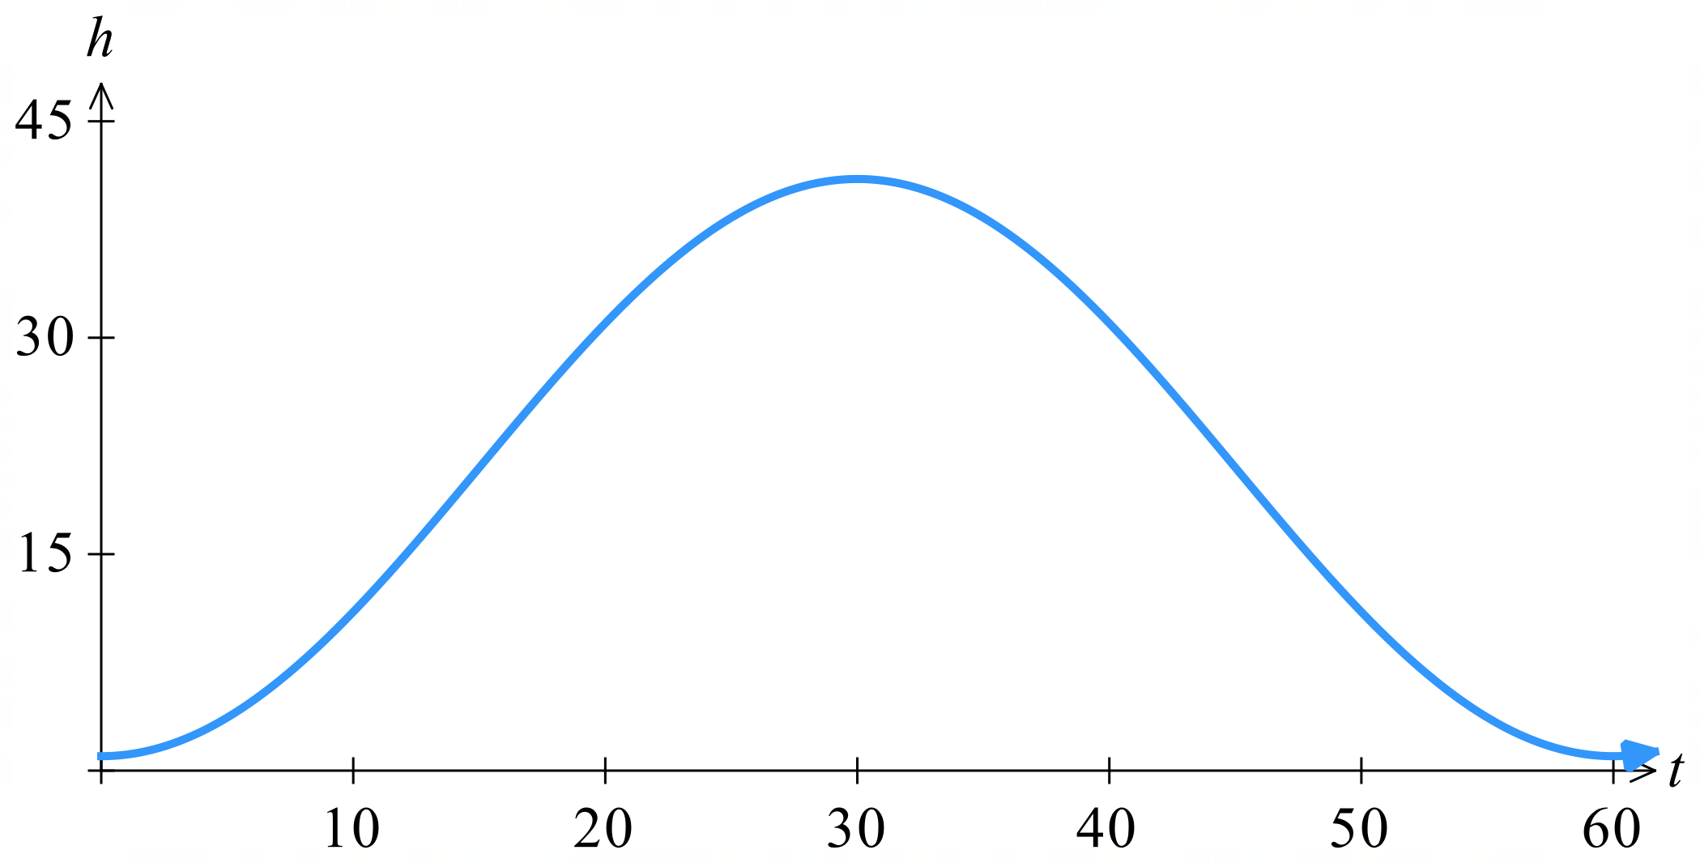
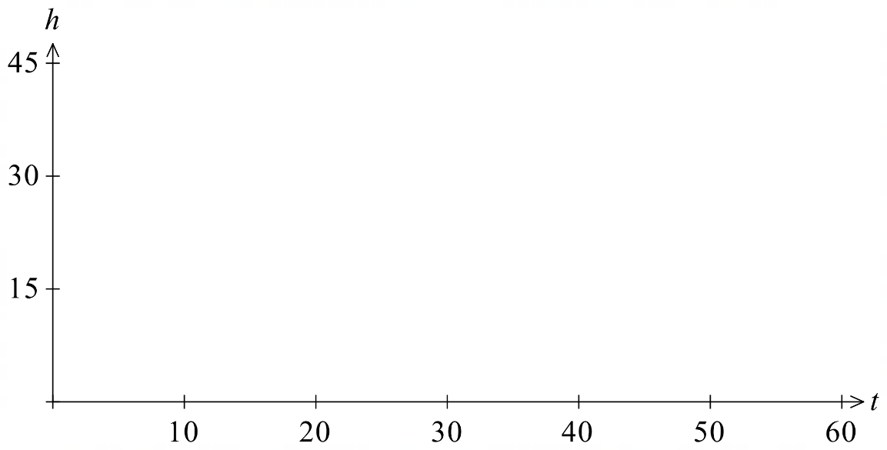
- Sketch the graph of $h\left(t\right)$ for the first two minutes.
Period: $\frac{2π}{\left(\frac{π}{30}\right)}$ $=60$ seconds
Mean position: 21 m
Amplitude: 20 m

- What is the passenger’s height above the ground after 20s?  $$h\left(20\right)= -20\cos\left(\frac{20π}{30}\right) + 21 \\ = -20\cos\left(\frac{2π}{3}\right)+ 21 \\ = -20\left(-\frac{1}{2}\right) + 21 \\ = 10 + 21 \\ = 31 m$$ | - Emily wants to film a video when the Ferris wheel is above 38 m, how long, to the nearest second, does she have to do this in the two minutes?  $$h(t) = 38: \\ -20\cos\left(\frac{πt}{30}\right)+ 21 = 38 \\ -20\cos\left(\frac{πt}{30}\right)= 17 \\ cos\left(\frac{πt}{30}\right)= -\frac{17}{20} \\ \frac{πt}{30}= cos^{-1}\left(-\frac{17}{20}\right) \\ \frac{πt}{30}=2.58678… \\ t = 24.7 s$$  Using the graph, the Ferris wheel is first above 38 m after 24.7 s. The peak is at 30 s, using symmetry, the Ferris wheel will be above 38 m for $\left(30-24.7\right)×4≈$21 s
- Guided Practice
The rise and fall of the tide at a harbour can be modelled by the function $y=7+3\cos\left(\frac{4πt}{25}\right)$ where $y$ is the water depth and $t$ is the number of hours after the first high tide at 2 am.
- How long, in hours, is the time between successive high tides?
$$Period = \frac{2π}{a}$$
$$= \frac{2π}{\left(\frac{4π}{25}\right)}$$
$$=12.5 hours$$
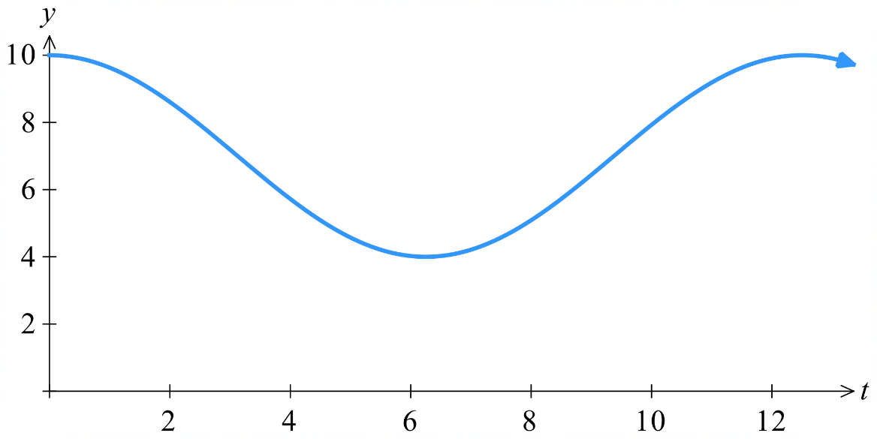
- Sketch the graph for one cycle.

- What is the lowest level of water in the harbour, and at time does this occur?

Lowest position occurs when $\cos{(\frac{4πt}{25}})=-1$
$$t=\frac{25}{4}=6.25$$
4 metres at $8:15$ am
- A bridge obstructs a ship’s exit from the harbour. The ship can only leave if the water depth is 8.5 m or less. When is the earliest the ship can leave, to the nearest minute?

$$8.5=7+3\cos\left(\frac{4πt}{25}\right)$$
$$3\cos\left(\frac{4πt}{25}\right)=1.5$$
$$\cos\left(\frac{4πt}{25}\right)=\frac{1}{2}$$
$$\frac{4πt}{25}=\frac{π}{3}$$
$$t=\frac{25}{15}=2° 05'$$
2 hr 5 min after 2am is: 4:05 am

- Guided Practice
The tide at a point on the NSW coast can be modelled using the equation $y = k\cos{nt}+c$.
At a beach in NSW, over a day, the average difference between high and low tides is 1.6 metres and the average time between high tide and low tide is 6 hours. The depth at low tide is 0.2 metres.

- Identify the amplitude, period, and mean position.

Amplitude: 0.8 m,
Period: 12 hours
Mean position = $0.2+0.8=1$ metre
- Hence find the value of $k, n,$ and $c$ then sketch the graph for one cycle.
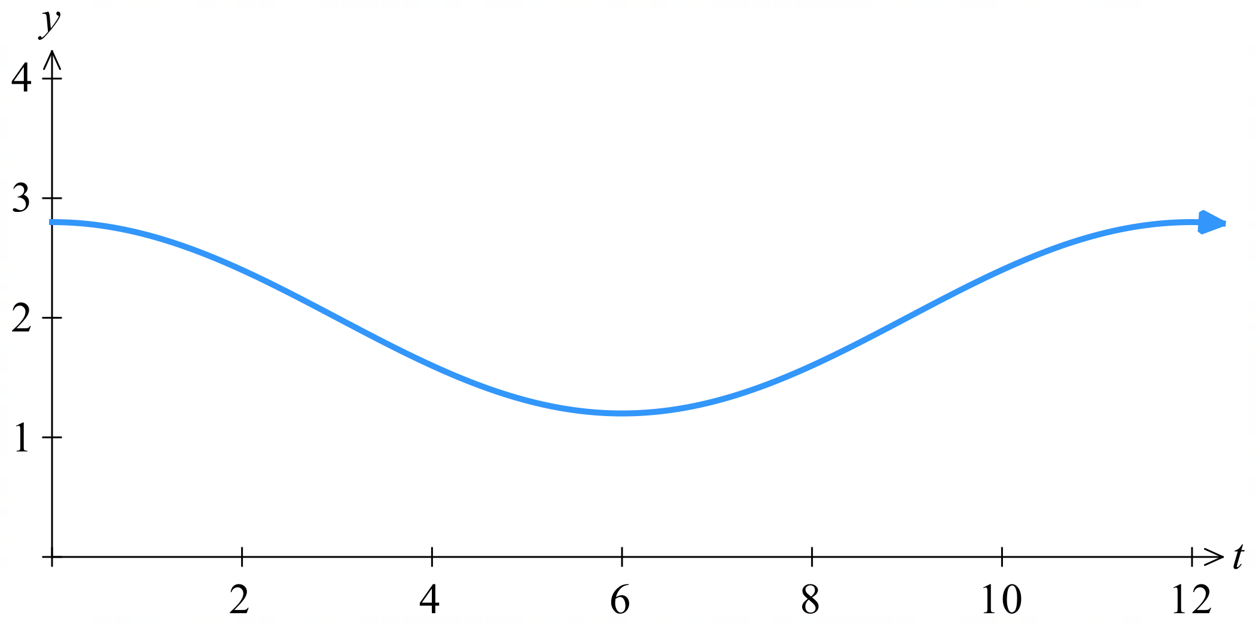

$$k=0.8$$

$$\frac{2π}{n}=12$$
$$n=\frac{π}{6}$$

$c=1$ metre

$$∴y=0.8\cos{\frac{πt}{6}}+1$$
- What is the depth of water 2 hours after low tide?

Low tide occurs when $\cos\left(\frac{πt}{6}\right)=-1$
This first occurs at $t=6$
So $y\left(8\right)=0.6$
0.6 m

Foundation
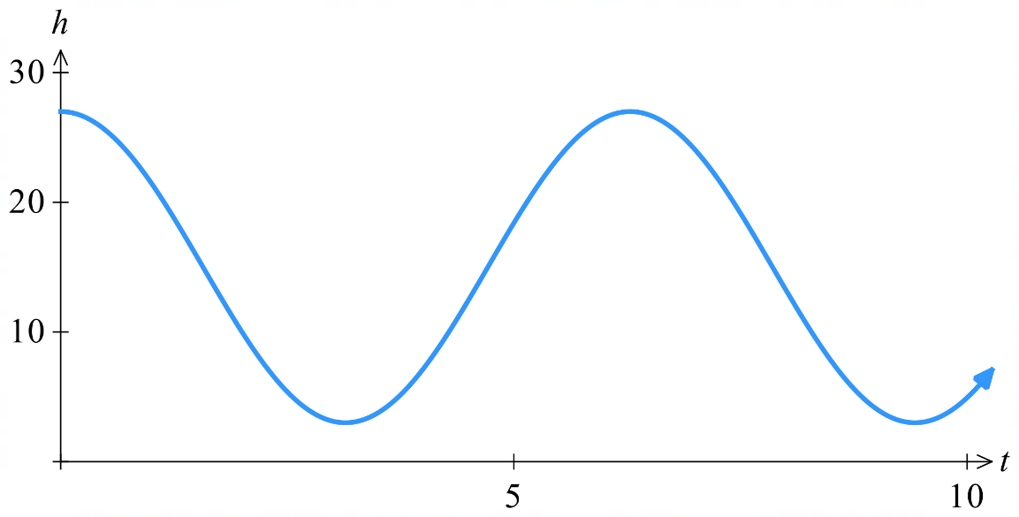
- A vertical spring is pulled down and then let go. It bounces back up and down again according to the equation $h = 12 cos t + 15$ where $h$ is the height of the spring in cm and $t$ is time in seconds. The graph of its motion is shown below for the first 10 seconds.

  - Describe the significance of the 15 in the equation.

15 is the mean, or equilibrium, position of the spring.
  - What are the maximum and minimum heights of the spring?
Maximum = 15 + 12 = 27 cm
Minimum = 15 - 12 = 3 cm
  - What is the height of the spring after $π$ seconds?
$$h = 12\cos{π}+ 15 = 3 cm$$

  - At what times will the spring be at its minimum height?
Minimum when $cos t = -1$
$t = π, 3π, 5π$, ... seconds

- The depth of water in Dolphin Bay varies according to the tides. The depth is modelled by the equation $x = 2 cos\left(\frac{π}{7}t\right) + 8$, where $x$ metres is the depth and $t$ hours is the time since the last high tide. Last Saturday, it was high tide at 7 am.
  - How deep is the bay at high tide?
$$x(0) = 2 cos(0) + 8 = 10 metres$$
  - How deep is the bay at low tide?
$$x(6) = 2 cos(π) + 8 = 6 metres$$
  - When did the first low tide after 7 am occur?
Low tide when $cos\left(\frac{πt}{7}\right)= -1$
$$\frac{πt}{7}= π$$
t = 7 hours after 7 am = 2 pm
  - At what time last Saturday morning was the depth 9 metres?
$$9 = 2 cos\left(\frac{πt}{7}\right)+ 8$$
$$cos\left(\frac{πt}{7}\right)=\frac{1}{2}$$
$$\frac{πt}{7}=\frac{π}{3}$$
t = $\frac{7}{3}=2\frac{1}{3}$ hours after 7 am = 9:20 am

Development
- The function $T = 15 cos\left(\frac{πt}{6}\right) + 20$ models the average monthly temperatures in Nelson Springs, starting in January.
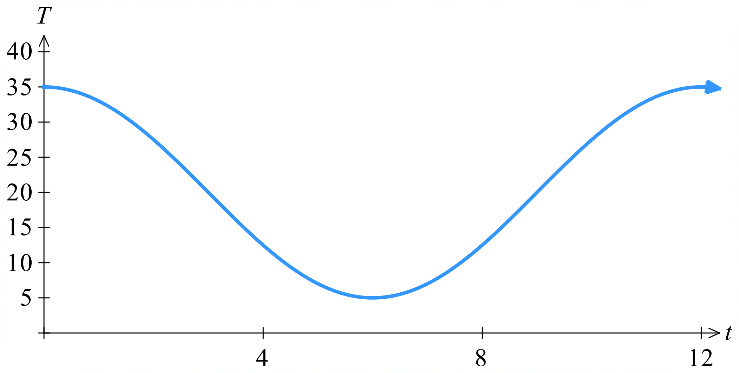

  - Identify the amplitude, period and mean position of the function.
Amplitude = 15
Period = $\frac{2π}{\frac{π}{6}}$ = 12 months
Mean position = 20 °C
  - Solve $15 cos\left(\frac{πt}{6}\right)+20=35$ and explain the meaning of the solutions.
$$5 cos\left(\frac{πt}{6}\right)+ 20 = 35$$
$$15 cos\left(\frac{πt}{6}\right)= 15$$
$$cos\left(\frac{πt}{6}\right)= 1$$
$$\frac{πt}{6}= 0, 2π, 4π, ...$$
$t = 0, 12, 24$, ... months
Temperature of 35° occurs in January of each year ($t$ = 0 corresponds to January).

- The voltage, $V$ volts, supplied by an electrical outlet is described by the sine function
$V = k sin at + c$, where $k$, $a$ and $c$ are constants, $t$ is measured in seconds and $k>0$.
  - If the voltage, $V$, oscillates between -240 volts and 240 volts, find the value of $k$ and $c$.

$$k = 240$$
$$c = 0$$
  - If it has a frequency of 50 Hz (meaning 50 cycles per second), find the value of $a$.

Frequency = 50 Hz, so period = $\frac{1}{50}$ s
$$a =\frac{2π}{\frac{1}{50}}= 100π$$
  - Determine the voltage $(V)$ function as a transformation of the sine function.

$$V(t)=240 sin(100πt)$$
- A set of tidal waves has a maximum height of 20 m and a minimum height of 6 m.
The waves break every 10 seconds.
  - Find the equation of a sine function $y=k\sin\left(at\right)+c$ that describes the wave motion.
Mean position = $\frac{20 + 6}{2}$ = 13 m
Amplitude = $\frac{20 - 6}{2}$ = 7 m
Period = 10 s, so $B =\frac{2π}{10}=\frac{π}{5}$
$$y = 7 sin\left(\frac{πt}{5}\right)+ 13$$
  - Find the first 4 times that the waves reach their maximum height.
$$20=7\sin\left(\frac{πt}{5}\right)+13$$
$$sin\left(\frac{πt}{5}\right)= 1$$
$$\frac{πt}{5}=\frac{π}{2},\frac{5π}{2},\frac{9π}{2},\frac{13π}{2}$$
$$t = 2.5, 12.5, 22.5, 32.5 seconds$$
  - Find the first time that the waves reach their minimum height.
Minimum when $sin\left(\frac{πt}{5}\right) = -1$
$$\frac{πt}{5}=\frac{3π}{2}$$
$t = 7.5$ seconds
  - When will the height of the waves be in the centre?

Centre height when $sin\left(\frac{πt}{5}\right) = 0$
$$\frac{πt}{5}= 0, π, 2π, 3π, 4π, 5π, ...$$
$$t = 0, 5, 10, 15, 20, 25, ... seconds$$

- The height of the water, $h$ metres, in a bay varies over time and can be modelled by a cosine function of the form $h(t) = k cos at + c$, where $k$, $a$ and $c$ are constants and $t$ represents the number of hours after midnight. On a particular day off the coast of South Australia, a high tide of 4.5 metres occurred at 6:00 am and a low tide of 0.5 metre occurred at 12:00 pm.
  - Determine a model for the height, $h$ metres, of the water as a function of time, $t$ hours, since midnight by finding the values of $k$, $a$ and $c$.
$$k =\frac{4.5 - 0.5}{2}= 2$$
$$c =\frac{4.5 + 0.5}{2}= 2.5$$
Half-period = 6 hours, so period = 12 hours
$$a =\frac{2π}{12}=\frac{π}{6}$$

  - Hence write the rule of $h(t)$.
$$h\left(t\right)= 2 cos\left(\frac{πt}{6}\right)+ 2.5$$
  - At what time does the second high tide occur?
Next high tide: period = 12 hours after 6 am = 6 pm

- A Ferris wheel with a radius of 35 m rotates once every 90 seconds.
Passengers enter a cabin at the loading point, which is 2 m above level ground.
The height, $h(t)$ metres, above the ground is given by $h(t) = -35 cos\left(\frac{πt}{45}\right) + 37$,
where $t$ seconds is the time after leaving the lowest level.
  - Sketch the graph of $h(t)$ for a 3-minute period after a cabin passes the loading point and state the coordinates of the $h$ intercept.
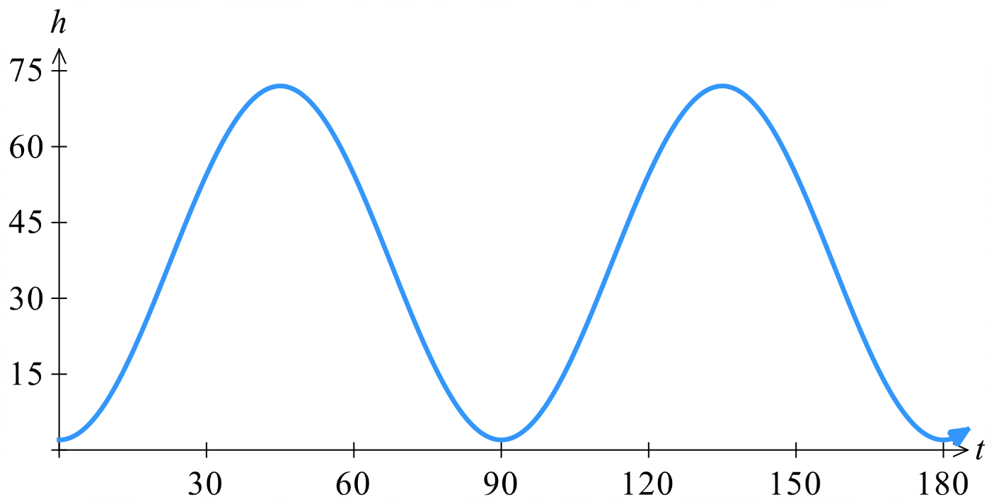
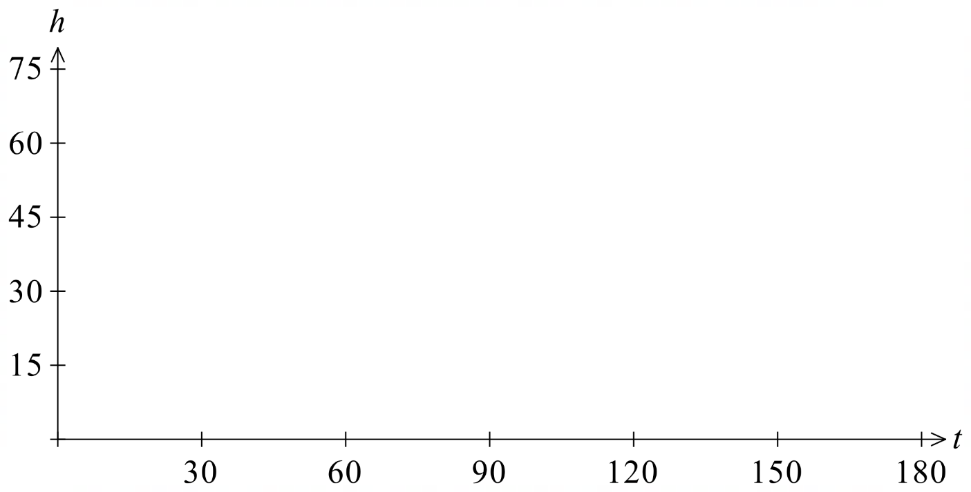

$h$(0) = 2
  - What is a cabin's height above the ground in metres after 30 seconds?
Give your answer correct to 1 decimal place.

$$h(30) = -35 cos\left(\frac{π\left(30\right)}{45}\right) + 37 = 54.5 m$$
  - After how many seconds will the cabin be 40 m above the ground for the first time?
Give your answer correct to two decimal places.
$$40 = -35 cos\left(\frac{πt}{45}\right)+ 37$$
$$3 = -35 cos\left(\frac{πt}{45}\right)$$
$$cos\left(\frac{πt}{45}\right)= -\frac{3}{35}$$
$$\frac{πt}{45}= cos^{-1}\left(-\frac{3}{35}\right)$$
$$t =\frac{45}{π}cos^{-1}\left(-\frac{3}{35}\right)= 23.73 s$$

- Scientists monitoring a population of penguins on Heard Island found that the number of penguins varies between a high of 900 at the start of the year and a low of 700 on 30 June and is approximated by the cosine function $P(t) = k cos at + c$, where $t$ is the number of months since the start of the year, and $k$, $a$ and $c$ are constants.
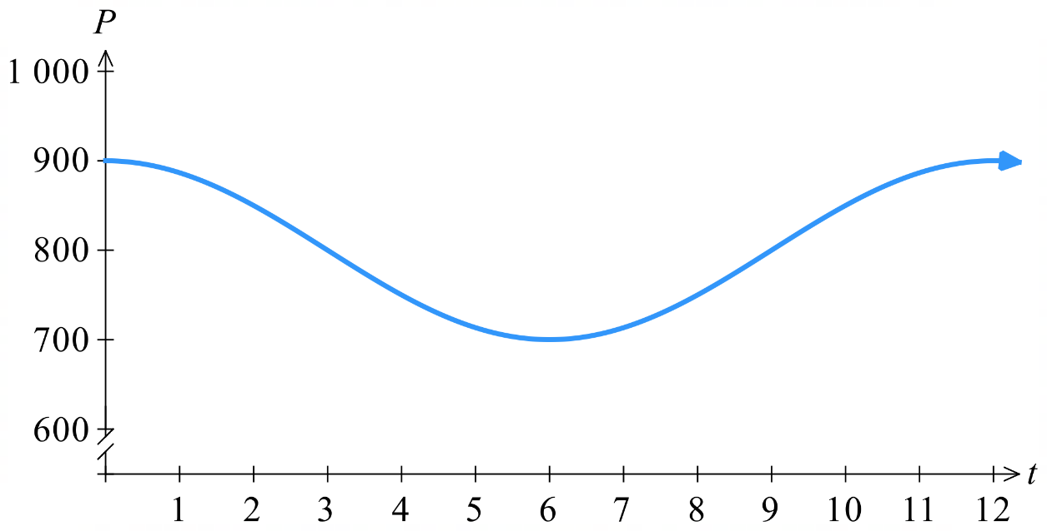
  - Sketch a graph of the penguin population over a whole year.

  - Find the values of $k$, $a$ and $c$ for the function.
$$k =\frac{900 - 700}{2}= 100$$
$$c =\frac{900 + 700}{2}= 800$$
Half-period = 6 months, period = 12 months
$$a =\frac{2π}{12}=\frac{π}{6}$$
  - According to the population function, how many penguins will there be on the island on 31 March?

$$P\left(3\right)= 100 cos\left(\frac{π\left(3\right)}{6}\right)+ 800 = 800$$

Mastery
- The temperature $T °C$ inside the school classroom during a day in February can be modelled by the equation $T=15 sin\left(\frac{πt}{12}\right)+20$, where $t$ is the number of hours after 9.00 am and $0≤t≤12$.
  - Sketch the graph of the temperature, $T °C$, inside the school classroom over the 12-hour period; state the coordinates of the $T$ intercept, the maximum temperature, and the time at which this occurs.
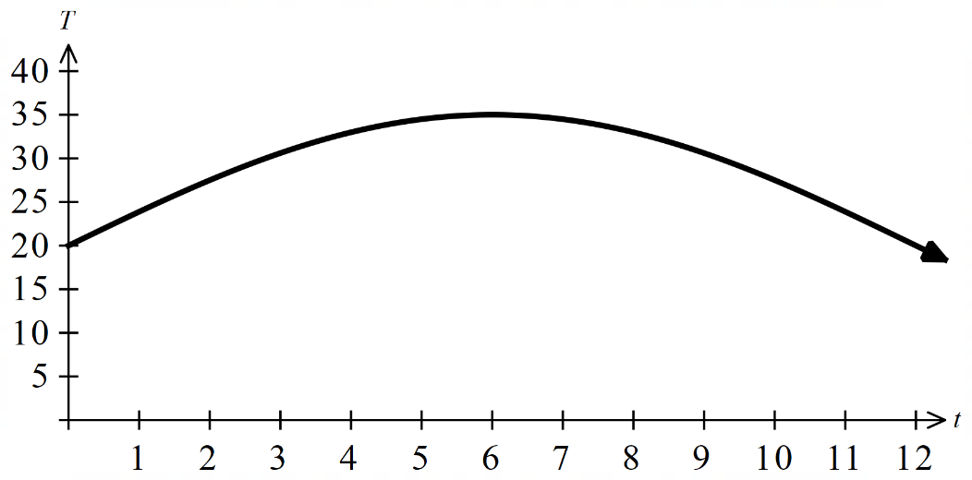
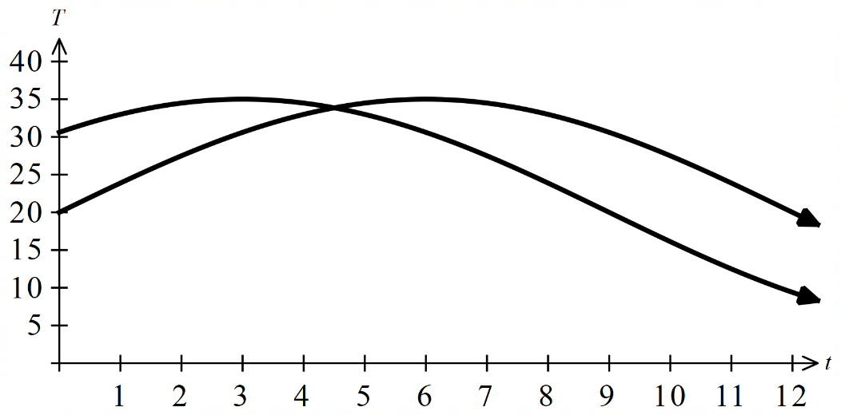

$T\left(0\right)=20°C$, max temperature at $T\left(6\right)=35°C$
  - What is the temperature inside the room at 9:00 am?
$$T(0) = 15 sin(0) + 20 = 20°C$$
  - What is the temperature in the room at midday?
$$T\left(3\right)= 15 sin\left(\frac{π\left(3\right)}{12}\right)+ 20 =30.6 °C$$
  - At what times is the temperature inside the room equal to 30 °C?
$$30 = 15 sin\left(\frac{πt}{12}\right)+ 20$$
$$10 = 15 sin\left(\frac{πt}{12}\right)$$
$$sin\left(\frac{πt}{12}\right)=\frac{2}{3}$$
$$\frac{πt}{12}= sin^{-1}\left(\frac{2}{3}\right)or \left(π - sin^{-1}\left(\frac{2}{3}\right)\right)$$
$$t = 2.8 hours \left(11:47 am\right)$$
$$or t = 9.2 hours (6:13 pm)$$
  - State the percentage of time that the temperature inside the room was at least 30 °C.
$$Time at ≥30°C: 9.2 - 2.8 = 6.4 hours$$
$$Percentage: \left(\frac{6.4}{12}\right)\left(100\right)= 53.3\%$$
  - It is known that the temperature inside the classroom follows the outside temperature by
3 hours, that is $T_{out}=15\sin\left(\frac{π}{12}\left(t+3\right)\right)+20$. Sketch both graphs on the same axis above.
Same graph shifted left by 3.
  - When are the temperatures the same and what temperature is this?
The peak of inside temperature is at $t=6$
The peak of the outside temperature is at $t=3$
As the outside temperature decreases, the inside temperature increases.
Since the two graphs are identical except for shifting, the rate of change of temperature is symmetrical.
Therefore, temperatures will be equal at the midpoint $t=4.5$ at $T\left(4.5\right)≈33.86°C$
algebraic method is to set the equations equal and solve using:
$if\sin{X}=\sin{Y}, then X=Y or X=π-Y$ ($y$-coordinates in unit circle are equal in first or second quadrant)
Only the second case would yield a valid solution of $4.5$
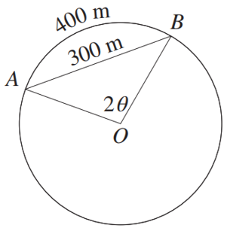
- The diagram shows points A and B on a circle with centre O, where $∠AOB = 2θ$, chord AB has length 300 metres, and the minor arc AB has length 400 metres.
  - Show that sin θ = $\frac{3θ}{4}$.

Arc length formula: $l=rθ$
$$400=r\left(2θ\right)$$
$$r=\frac{200}{θ}$$
Method 1: Sine rule with double angle formula  (extension students only)  $$\frac{\sin{2θ}}{300}=\frac{\sin\left(\frac{180-2θ}{2}\right)}{r}$$  $$\frac{\sin{2θ}}{300}=\frac{\sin\left(90-θ\right)}{\left(\frac{200}{θ}\right)}$$  $$\frac{2\sin{θ}\cos{θ}}{300}=\frac{\cos{θ}}{\left(\frac{200}{θ}\right)}$$  $$\frac{2\sin{θ}}{300}=\frac{θ}{200}$$  $$∴\sin{θ}=\frac{3θ}{4}$$ | Method 2: Construct right–angled triangle:  Draw the perpendicular from O to the midpoint of AB.  Using right–angled trig in this triangle, $\sin{θ}=$ $\frac{150}{r}$  $$\sin{θ}=\frac{150}{\left(\frac{200}{θ}\right)}$$  $$∴\sin{θ}=\frac{3θ}{4}$$

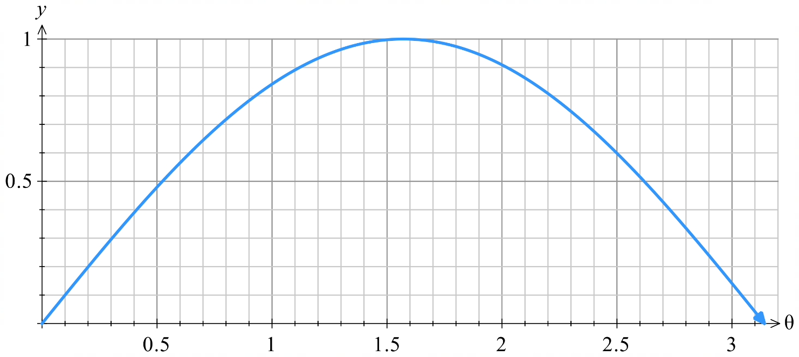
  - Use the graph of $y=\sin{θ}$ below to determine the value of θ, correct to one decimal place.

Sketch $y=$ $\frac{3θ}{4}$ and identify point of intersection
θ ≈ 1.3 radians
  - Hence find $∠AOB$ in radians, correct to one decimal place, and show that the radius of the circle is about 154 metres.

$$∠AOB = 2θ ≈ 2.6 radians$$
$$l= rθ$$
$$400 = r\left(2.6\right)$$
$$r =\frac{400}{2.6}≈ 154 metres$$

Exam Questions
- HSC Advanced Sample Question Band 4
On any given day, the depth of water in a river is modelled by the function $h(t)=14+8sin\left(\frac{πt}{12}\right)$, $0 ≤ t ≤ 24$ where $h$ is the depth of water, in metres, and $t$ is the time, in hours, after 6 am.
  - Find the minimum depth of the water in the river.
$$∴ h_{min}= 14 - 8 = 6 m$$

  - Find the values of $t$ for which $h(t) = 10.$

$$14 + 8sin\left(\frac{πt}{12}\right)= 10$$
$$sin\left(\frac{πt}{12}\right)= -\frac{1}{2}$$
$$\frac{πt}{12}=\frac{7π}{6} or \frac{11π}{6}$$
$$∴t=14 or 22$$
https://www.desmos.com/calculator/wxyihnd9ab

- 2018 HSC Advanced Band 5
The length of daylight, $L(t)$, is defined as the number of hours from sunrise to sunset, and can be modelled by the equation
$$L(t) = 12 + 2cos\left(\frac{2πt}{366}\right)$$
where $t$ is the number of days after 21 December 2015, for $0 ≤ t ≤ 366$.
  - Find the length of daylight on 21 December 2015.
L(0) = 12 + 2cos(0) = 14 hours
  - What is the shortest length of daylight?

$$∴ L_{min}= 12 - 2 = 10 hours$$
  - What are the two values of $t$ for which the length of daylight is 11?

$$12 + 2cos\left(\frac{2πt}{366}\right)= 11$$
$$cos\left(\frac{2πt}{366}\right)= -\frac{1}{2}$$
$$\frac{2πt}{366}=\frac{2π}{3} or \frac{2πt}{366}=\frac{4π}{3}$$
$$∴ t = 122 or 244 \left(0 ≤ t ≤ 366\right)$$

- HSC Advanced Sample Question Band 5
The population of wombats in a particular location varies according to the rule
$$n(t)=1200+400cos\left(\frac{πt}{3}\right)$$
where $n$ is the number of wombats and $t$ is the number of months after 1 March 2018.
  - Find the period and amplitude of the function $n$.
Period: $\frac{2π}{\left(\frac{π}{3}\right)}$ = 6 months
Amplitude: 400
  - Find the maximum and minimum populations of wombats in this location.

max = 1200 + 400 = 1600 wombats
min = 1200 - 400 = 800 wombats
  - Find $n(10)$.
n(10) = 1000
  - Over the 12 months from 1 March 2018, find the fraction of time when the population of wombats in this location was less than $n(10)$.

$$1200 + 400cos\left(\frac{πt}{3}\right)< 1000$$
$$cos\left(\frac{πt}{3}\right)< -\frac{1}{2}$$
$$\frac{πt}{3}=\frac{2π}{3},\frac{4π}{3}$$
$$t = 2 and 4$$
Using period of 6, other two times in domain are $t=8 and 10$
Total time = 4 months
Fraction = $\frac{4}{12}$ = $\frac{1}{3}$
A sketch is useful here for solving the inequality
https://www.desmos.com/calculator/hkwurcsxqs

- 2024 HSC Advanced Band 5
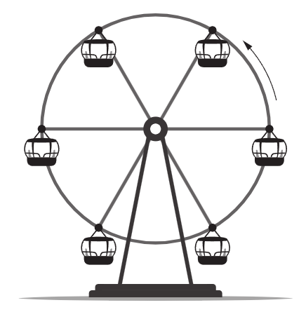
Anna is sitting in a carriage of a Ferris wheel which is revolving. The height, $A(t),$ in metres above the ground of the top of her carriage is given by
$$A\left(t\right)= c - k cos\left(\frac{πt}{24}\right),$$
where $t$ is the time in seconds after Anna's carriage first reaches
the bottom of its revolution and $c$ and $k$ are constants.

The top of a carriage reaches a greatest height of 39 metres
and a lowest height of 3 metres.

  - Find the value of $c$ and $k$.
$$c =\frac{39 + 3}{2}= 21$$
$$k =39-21= 18$$
  - How many seconds does it take for one complete revolution of the Ferris wheel?
Period = $\frac{2π}{\left(\frac{π}{24}\right)}$ $=48$ seconds
  - Billie is in another carriage. The height, B(t), in metres above the ground of the top of her carriage is given by
$$B(t) = c - kcos\left(\frac{π}{24}\left(t - 6\right)\right)$$
where $c$ and $k$ are as found in part a.
During each revolution, there are two occasions when Anna's and Billie's carriages are at the same heights. At what two heights does this occur? Give your answer correct to 2 decimal places.
This question is most easily solved by drawing a sketch.
The two carriages are a phase shift of 6 seconds apart.
They will be at the same height $±3$ seconds from the peak and the trough.
$∴$ they will be at the same height at $t=0+3$ and $t=24+3$
$$∴A\left(3\right)=4.37, A\left(27\right)=37.63$$
Check: $B\left(3\right)=4.37, B\left(27\right)=37.63$
https://www.desmos.com/calculator/aladfjyg3t

- 2022 HSC Advanced Band 5
The depth of water in a bay rises and falls with the tide. On a particular day the depth of the water, $d$ metres, can be modelled by the equation
$$d = 1.3 - 0.6 cos\left(\frac{4πt}{25}\right)$$
where $t$ is the time in hours since low tide.
  - Find the depth of water at low tide and at high tide.
Low Tide = 1.3 - 0.6(1) = 0.7 m
High Tide = 1.3 - 0.6(-1) = 1.9 m
  - What is the time interval, in hours, between two successive low tides?
Time between two low tides = Period of equation $(n)$
$$\frac{2π}{n}=\frac{4π}{25}$$
$$\frac{n}{2π}=\frac{25}{4π}$$
$$n =\frac{25}{2}hours$$
  - For how long between successive low tides will the depth of water be at least 1 metre?

$$Find t when d = 1$$
$$1.3 - 0.6 cos\left(\frac{4πt}{25}\right) = 1$$
$$-0.6 cos\left(\frac{4πt}{25}\right)= -0.3$$
$$cos\left(\frac{4πt}{25}\right)=\frac{1}{2}$$
$$\frac{4πt}{25}=\frac{π}{3},\frac{5π}{3}$$
$$t =\frac{25}{12},\frac{125}{12}$$
$$∴ Time between low tides where water depth ≥ 1 m$$
$$=\frac{125}{12}-\frac{25}{12}$$
$$=\frac{100}{12}$$
$$=\frac{25}{3}hours$$

- 2009 HSC Advanced Band 6
Between 5 am and 5 pm on 3 March 2009, the height, $h$, of the tide in a harbour was given by
$$h = 1 + 0.7 sin\left(\frac{πt}{6}\right) for 0 ≤ t ≤ 12$$
where $h$ is in metres and $t$ is in hours, with $t = 0$ at 5 am.
  - What is the period of the function $h$?
$$h = 1 + 0.7 sin\left(\frac{πt}{6}\right)for 0 ≤ t ≤ 12$$
$$T =\frac{2π}{\left(\frac{π}{6}\right)}$$
$$= 12 hours$$
  - What was the value of $h$ at low tide, and at what time did low tide occur?
min = 1 – 0.7
= 0.3 metres

$$Since\sin{x} = -1 when x =\frac{3π}{2}$$
$$\frac{πt}{6}=\frac{3π}{2}$$
$$t =9 hours$$
Low tide occurs at 2pm (5 am + 9 hours)
  - A ship is able to enter the harbour only if the height of the tide is at least 1.35 m.
Find all times between 5 am and 5 pm on 3 March 2009 during which the ship was able to enter the harbour.

Find $t$ when $h= 1.35$
$$1 + 0.7 sin\left(\frac{πt}{6}\right)= 1.35$$
$$0.7 sin\left(\frac{πt}{6}\right)=0.35$$
$$sin\left(\frac{πt}{6}\right)=\frac{1}{2}$$
$$\frac{πt}{6}=\frac{π}{6},\frac{5π}{6},\frac{13π}{6}, …$$
$$t=1, 15, 13…$$
$$t = 1, 5 (0 ≤ t ≤ 12)$$

Using a sketch of the graph,
https://www.desmos.com/calculator/1asdw5lccb
$$sin\left(\frac{πt}{6}\right)≥\frac{1}{2} when 1 ≤ t ≤ 5$$
∴ Ship can enter the harbour between 6 am and 10 am.

